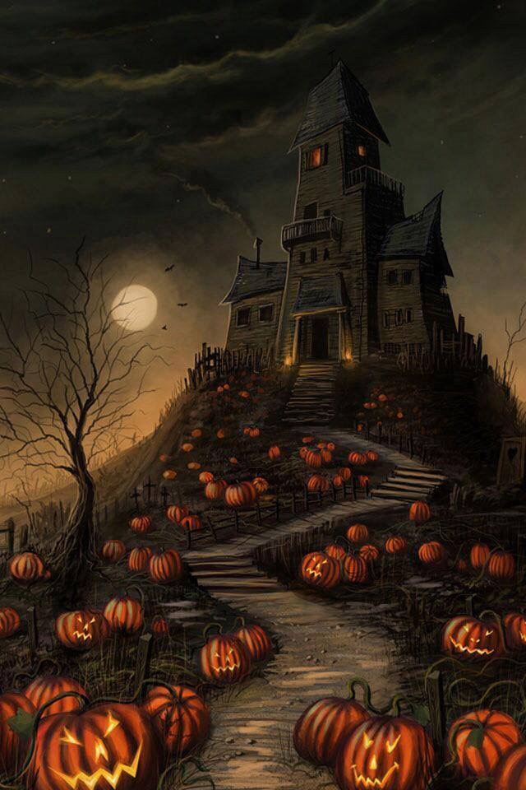
11th Annual
SRHS Scary Strings Concert
Featuring:
South River High School &
Towson University Symphony Orchestras

Wednesday, October 30, 2019
6:30PM
SRHS Auditorium

Free Admission with Harvest 4 the Hungry Food Donation
(Costume Contest with Prizes!)

